<https://www.sqlite.org/download.html> -SQLite

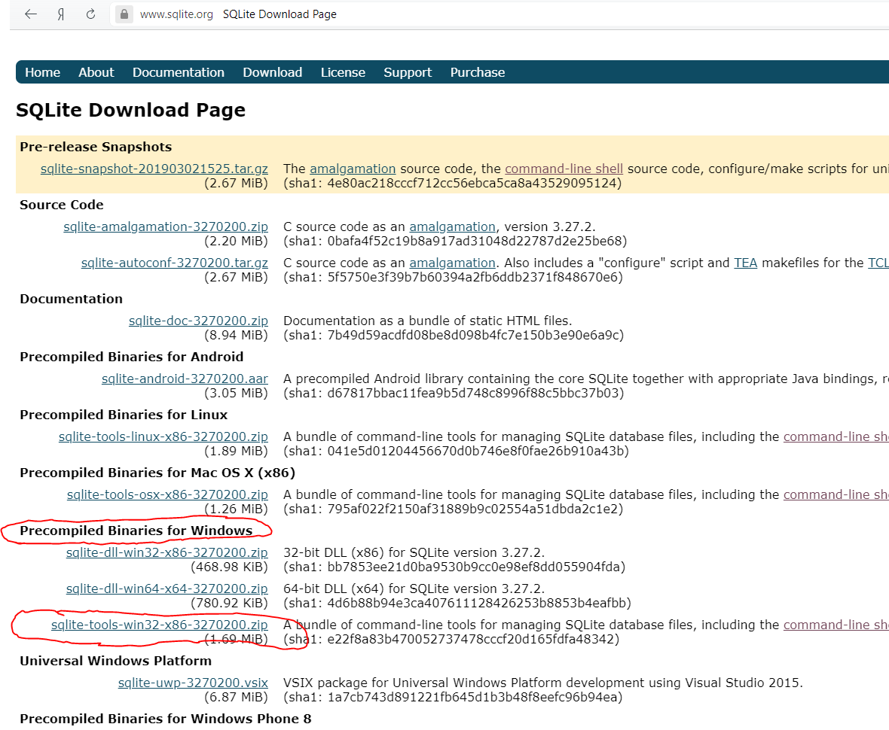

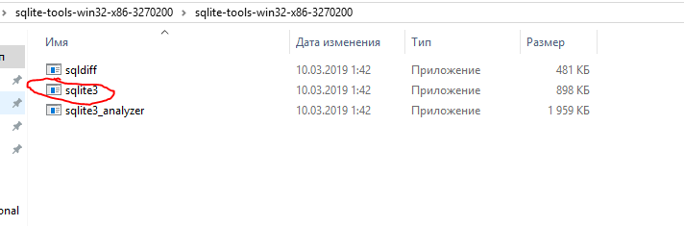

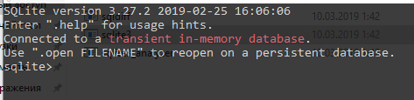

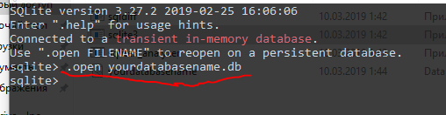

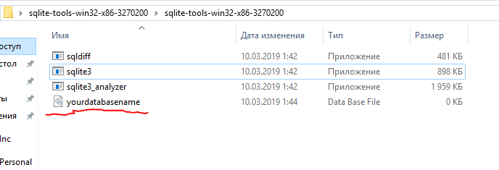

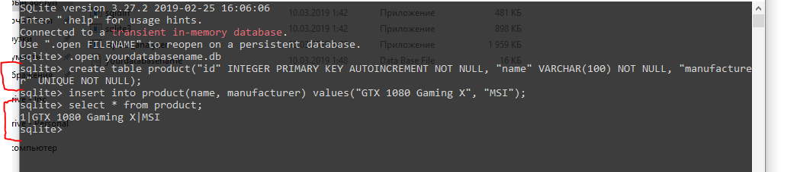

<https://bitbucket.org/xerial/sqlite-jdbc/downloads/> - sqlite jdbc driver for JAVA

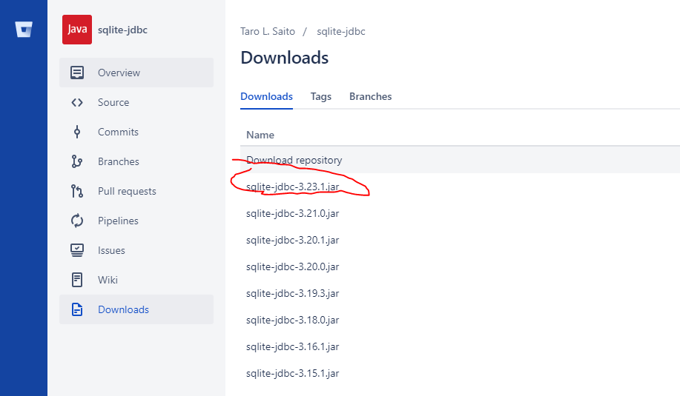

You can add library to the tomcat lib folder

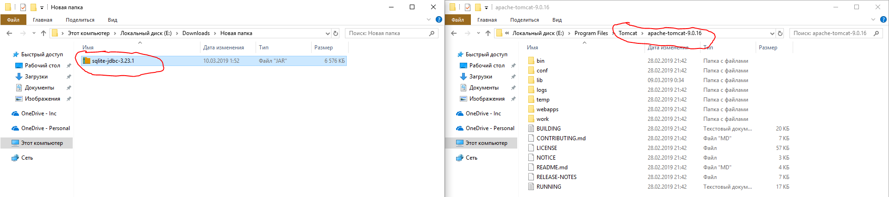

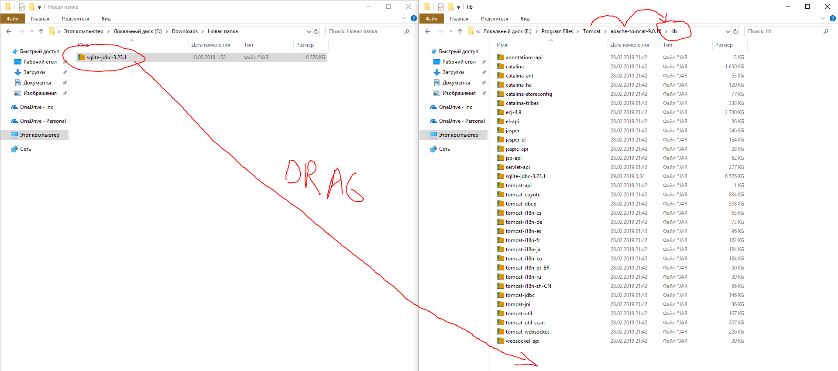

or create a new Maven project (How to create Maven project in Eclipse step-by-step – <https://drive.google.com/open?id=1CUhV4-QzI0ijxHkqMG2bAWZ629BvGzT2>)

and add this dependency in pom.xml:

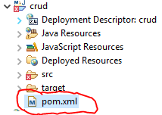

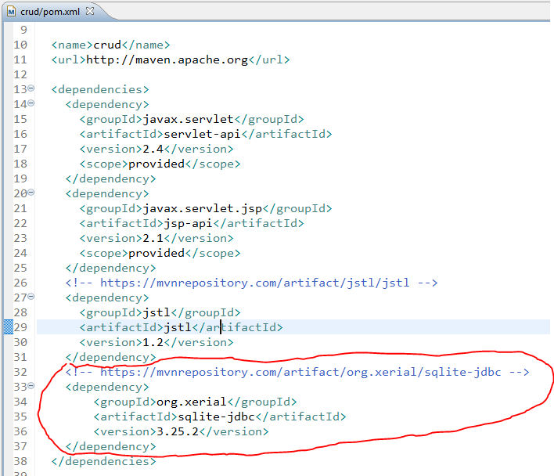

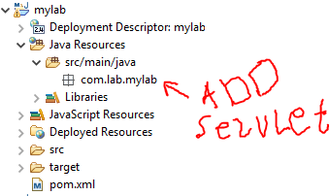

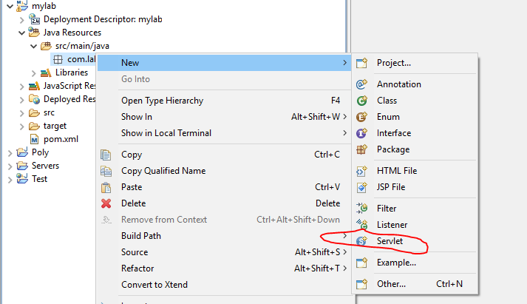

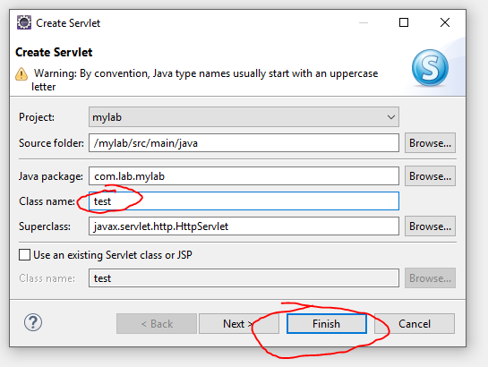

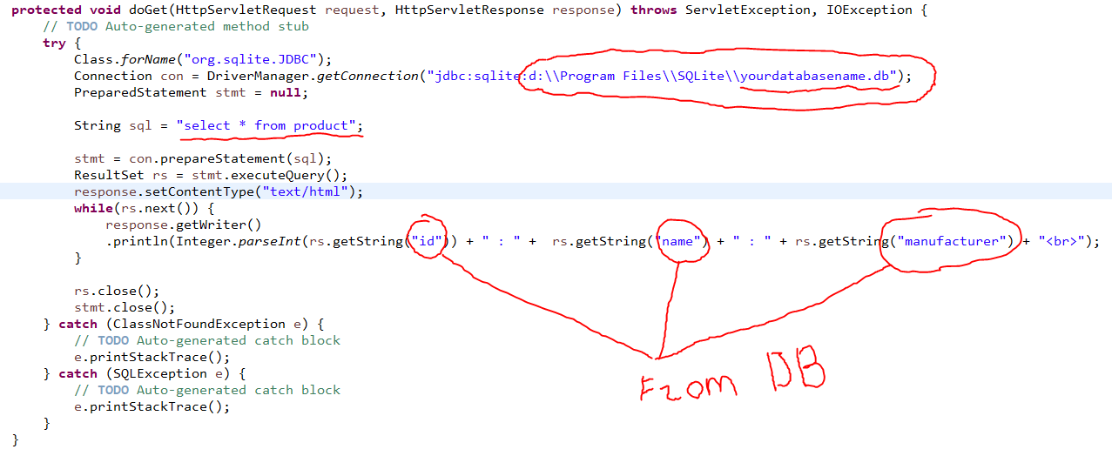

**protected** **void** doGet(HttpServletRequest request, HttpServletResponse response) **throws** ServletException, IOException {

// **TODO** Auto-generated method stub

**try** {

Class.*forName*("org.sqlite.JDBC");

Connection con = DriverManager.*getConnection*("jdbc:sqlite:d:\\Program Files\\SQLite\\yourdatabasename.db");

PreparedStatement stmt = **null**;

String sql = "select * from product";

stmt = con.prepareStatement(sql);

ResultSet rs = stmt.executeQuery();

response.setContentType("text/html");

**while**(rs.next()) {

response.getWriter()

.println(Integer.*parseInt*(rs.getString("id")) + " : " + rs.getString("name") + " : " + rs.getString("manufacturer") + "<br>");

}

rs.close();

stmt.close();

} **catch** (ClassNotFoundException e) {

// **TODO** Auto-generated catch block

e.printStackTrace();

} **catch** (SQLException e) {

// **TODO** Auto-generated catch block

e.printStackTrace();

}

}

